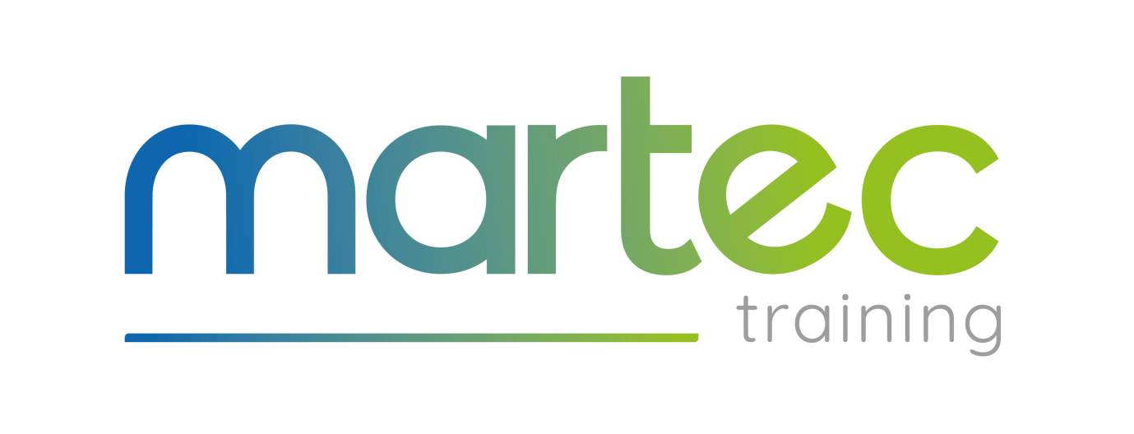

Martec Training Privacy Statement Using Children’s Personal Data
(Information for parents on how information about pupils is used in schools)

Introduction
This notice is to help you understand how and why we collect personal information about your child and what we do with that information. It also explains the decisions that you can make about your own information. If you have any questions about this notice please contact the Principal.

What is Personal Information?
Personal information is information that identifies your child as an individual and relates to them. This includes their contact details and next of kin. We may also hold information such as religion or ethnic group, photos and video recordings of your child are also personal information. Whilst the majority of pupil information you provide to us is mandatory, some of it is provided to us on a voluntary basis. In order to comply with the General Data Protection Regulations, we will inform you whether you are required to provide certain pupil information to us or if you have a choice in this.

How and Why Does Martec Training collect and Use Personal Information?
We set out below examples of the different ways in which we use personal information and where this personal information comes from. Martec Training’s primary reason for using your child’s personal information is to provide educational services to your child; we use the pupil data to support pupil learning, to monitor and report on pupil progress, to provide appropriate pastoral care, to assess the quality of our services, to comply with the law regarding data sharing.

- We obtain information about children from parent completed forms and from your child’s previous school. We may also get information from professionals such as doctors and from local authorities.
- We may have information about any family circumstances which might affect your child’s welfare or happiness.
- We may need information about any court orders or criminal petitions which relate to your family. This is so that we can safeguard the welfare and wellbeing of your child and the other pupils at Martec Training.
- We may take photographs or videos of your children at our events to use on social media and on our website. This is to show prospective parents and pupils what we do here and to advertise Martec Training. We may continue to use these photographs and videos after your child has left Martec Training.
- We may keep details of your address when your child leaves Martec Training so we can communicate with you and find out how your child is progressing.
- We may use information about you if we need this for historical research purposes or for statistical purposes.

The Categories of Pupil Information that we Collect, Hold and Share Include:
- Personal information (such as name, unique pupil number and address)
- Characteristics (such as ethnicity, language, nationality, country of birth)
- Attendance information (such as sessions attended, number of absences and absence reasons)
- Assessment information (such as basic skills assessment/GCSEs etc)
- Medical Information
- Details of Rewards and Sanctions
- Parent/Tutor Meetings.

Sharing Personal Information with Third Parties
- In accordance with our legal obligations, we may share information with local authorities, Ofsted and the Department for Education.
- On occasion, we may need to share information with the police.
- We may also need to share information with our legal advisers for the purpose of obtaining legal advice.
- If your child is not of British nationality we have to make sure that your child has the right to study in the UK.
- We may share some information with our insurance company, for example, where there is a serious incident.
- If your child leaves us to attend another school/college/training provider, we may need to provide that establishment with information about them, for example, for continuity of education, details of family circumstances for safeguarding reasons.
- We may share information about your children with others in your family, such as another parent or step-parent. For example, where this is part of our obligation to take care of your child, as part of our wider legal and regulatory obligations.
- We may need to share information if there is an emergency, for example, if your child is hurt whilst attending our training centre.

Our Legal Grounds for Using Your Information
This section contains information about the legal basis that we are relying on when handling your information. Legitimate interests: this means that the processing is necessary for legitimate interests except where the processing is unfair to you.

Martec Training relies on legitimate interests for most of the ways in which it uses your information. Specifically, we have a legitimate interest in:

- Providing educational services to your child;
- Safeguarding and promoting the welfare of your child (and other children);
- Promoting the objects and interests of Martec Training.
- Facilitating the efficient operation of Martec Training; and
- Ensuring that all relevant legal obligations of Martec Training are complied with.

In addition your personal information may be processed for the legitimate interests of others. If you object to us using your information where we are relying on our legitimate interests as explained above, please speak to the Principal.

Necessary for a Contract: We will need to use your children’s information in order to perform our obligations under our contract with you. For example, so that we can update you on your child’s progress and so that we can contact you if there is a concern.

Legal obligation: Where Martec Training needs to use your children’s information in order to comply with a legal obligation, for example, to report a concern to Children’s Services. We may also have to disclose your information to third parties such as the courts, the local authority or the police where legally obliged to do so.

Vital interests: For example, to prevent someone from being seriously harmed or killed.

Public interest: Martec Training considers that it is acting in the public’s interest when providing education. Martec Training must also comply with an additional condition where it processes special categories of personal information. These special categories are as follows: personal information revealing racial or ethnic origin, political opinions, religious or philosophical beliefs, trade union membership, genetic information, biometric information, health information and information about sex life or orientation.

Substantial public interest: The processing is necessary for reasons of substantial public interest.

Vital interests: To protect the vital interests of any person where that person cannot give consent, for example, if they are seriously hurt and are unconscious.

Legal claims: The processing is necessary for the establishment, exercise or defence of legal claims. This allows us to share information with our legal advisors and insurers.

Medical purposes: This includes medical treatment and the management of healthcare services.

We may ask for your consent to use your children’s information in certain ways. If we ask for your consent to use your personal information you can take back the consent at any time. Any use of your information before you withdraw your consent remains valid. Please speak to the Principal if you would like to withdraw any consent give.

Sending information to Other Countries
We may send your children’s information to other countries where:
- We store information on computer servers based overseas; or
- We communicate with you or your child when you are overseas (for example, during the summer holidays if you live in a different country).

The European Commission has produced a list of countries which have adequate data protection rules. The list can be found here:

http://ec.europa.eu/justice/data -protection/internationaltransfers/adequacy/index_en.htm

If the country that we are sending your information to is not on the list or, is not a country within the EEA (which means the European Union, Liechtenstein, Norway and Iceland) then it might not have the same level of protection for personal information s there is the UK.

For How Long Do We Keep Your Information?
We keep your children’s information for as long as we need to in order to educate and look after your child. We will keep some information after your child has left Martec Training, for example, so that we can find out what happened if you make a complaint.

In exceptional circumstances, we may keep your child’s information for a longer time than usual but we would only do so if we had a good reason and only if we are allowed to do so under data protection law. We can keep information about you for a very long time or even indefinitely if we need this for historical, research or statistical purposes.

Please see the Information and Records Policy for further details.

What Decisions Can You Make About Your Information?
From May 2018 data protection legislation gives you a number of rights regarding your information. Some of these are new rights whilst others build on your existing rights.

Your child’s rights are as follows:
- If information is incorrect you can ask us to correct it;
- They can also ask what information we hold about you and be provided with a copy. We will also give you extra information, such as why we use this information about you, where it came from and what types of people we have sent it to;
- They can ask us to delete the information that we hold about them in certain circumstances. For example, where we no longer need the information;
- They can ask us to send you, or another organisation, certain types of information about you in a format that can be read by computer;
- Use of information about you may be restricted in some cases. For example, if you tell us that the information is inaccurate we can only use it for limited purposes while we check its accuracy;

The Principal can give you more information about your data protection rights.

Further Information and Guidance
The Principal is the person responsible at Martec Training for managing how we look after personal information and deciding how it is shared.

Like other organisations we need to keep your information safe, up to date, only use it for what we said we would, destroy it when we no longer need it and most importantly – treat the information we get fairly. This notice is to explain how we use your personal information.

The Principal can answer any questions which you may have.

Please speak to the Principal if:
- You object to us using your information for marketing purposes e.g. to send you information about events. We will stop using your information for marketing purposes if you tell us not to; or
- You would like us to update the information we hold about you; or
- You would prefer that certain information is kept confidential.

If you consider that we have not acted properly when using your personal information you can contact the Information Commissioner’s Office – ico.org.uk.

Requesting Access to your Personal Data
Under data protection legislation, parents and pupils have the right to request access to information about them that we hold. To make a request for your personal information, or be given access to your child’s educational record, contact the Principal.

You also have the right to:
- Object to processing of personal data that is likely to cause, or is causing, damage or distress
- Prevent processing for the purpose of direct marketing.
- Object to decision being taken by automated means
- In certain circumstances, have inaccurate personal data rectified, blocked, erased or destroyed; and
- Claim compensation for damages caused by a breach of the Data Protection regulations.

If you have a concern about the way we are collecting or using your personal data, you should raise your concern with us in the first instance.

Contact:
If you would like to discuss anything in this privacy notice, please contact the Principal.

